Article Title: Understory plant community is taxonomically and functionally distinct five years after high severity fire.

Author Names:

Affiliations:

Corresponding Author:

Abstract (250 Word Max):

Keywords (1-7 words):

EDITING SCHEDULE

~~May 19 - May 22 Maddie~~

May 23 - May 26 Fern

May 27 - May 30 Ceci

May 31 – June 3 Cameron

June 4 - June 8 Ian

June 9 - June 13 Doan

June 14 Rachel

**1. INTRODUCTION**

Many factors, including early 20th century fire suppression policies, the loss of indigenous burning practices, nonnative animal grazing, an increasingly variable climate, and atmospheric warming and drying trends, have affected forest stand dynamics across western North America (Seager et al. 2015; Zhang et al. 2021; Belsky and Blumenthal 1997; Swetnam et al. 2016). As a result of, wildfire across the West has become more widespread, often occurring at atypical high severities and over longer fire seasons (Dennison et al., 2014; Balch et al., 2017; Burke et al., 2020; Mueller et al., 2020). This shift in fire regime is being exacerbated by a warming and drying climate (Mueller et al. 2020; Parks and Abatzoglou 2020; Wasserman and Mueller 2023), leading to an increasing proportion of wildfires burning at higher severities than previously recorded (Singleton et al. 2019). These shifts in climate, fire frequency, and severity can have significant consequences for forested plant communities, potentially leading alterations in regeneration strategies, changes in historically normal successional pathways, and even loss of species not adapted to high severity fires (Coop et al. 2020; Davis et al. 2019; Boucher et al. 2020).

In the dry conifer forests of western North America, historically adapted to a regime of frequent but low severity fires, these shifts in both climate and fire behavior may lead to alternate successional trajectories rather than recovery (Falk et al. 2022; Guiterman et al. 2022; Coop 2023). These forests were once maintained by surface fires occurring every 7 to 25 years, which limited ground fuel accumulation and promoted open canopies with diverse communities of plants in the understory. Typically, understory vegetation in these dry forested ecosystems is composed of fire-adapted perennial grasses, forbs, and some woody shrubs (Laughlin et al. 2008), all of which respond quickly to disturbance and play a key role in post-fire recovery dynamics. However, decades of altered fire management practices, coupled with increasing aridity across the West (Seneviratne et al. 2010; Overpeck & Udall 2020), have led to denser forest structures and altered fuel profiles, making them more vulnerable to stand-replacing, high-severity fires. These repeated, severe disturbances outside the normal disturbance regime may push these ecosystems beyond recovery thresholds, leading to state shifts that are difficult to reverse and have implications for ecosystem processes and associated socio-ecological services (Turner 2010). Predicting these novel successional trajectories will be key to future successful forest management in this period of anthropogenic change.

Because the bulk of the biodiversity in Western dry conifer forests is found in the understory, the understory plant communities respond more rapidly than the overstory following fire and play a key role in shaping successional trajectories. Although the responses of ecosystems to high-severity fire, and the underlying mechanisms, have yet to be fully understood, high-severity fire has been observed to reduce the diversity of understory communities (Richter et al. 2019). Communities recovering from high-severity fire exhibit a shift toward xerophilic and thermophilic species and a loss of mesic and sensitive species (Stevens et al. 2015, 2019; Dickson-Hoyle et al. 2024). In contrast, diversity is maximized when fires match historic regimes (Miller and Safford 2020; Weeks et al. 2023). In yellow pine forests of California, which are adapted to low-severity fire, Richter et al. (2019) found that diversity follows a strong unimodal curve: the extreme ends of a burn severity gradient (no fire and high-severity fire) had the lowest richness and diversity, while low and moderate severity resulted in the greatest richness and diversity.

To better understand the mechanisms underlying these shifts in diversity and composition following fire, forest ecologists have increasingly turned to functional traits as a tool to better understand plant community response to disturbance. For example, functional traits can offer a mechanistic framework for understanding plant community response to wildfire (Keeley et al. 2011). Plumanns-Pouton et al. were able to accurately predict the change in relative abundance of plant functional types, based on reproductive and life-history strategies, across an 81-year post-fire chronosequence in Australia (2024). While fire acts as an ecological filter by favoring certain functional traits, the nature of this filter shifts with increasing fire severity and the specific traits that confer advantages can vary depending on fire severity. For example, Taber and Mitchell (2023) found that, along a burn severity gradient, high-severity fire differentially selected species with lower leaf dry matter content (LDMC) and height in the first year after wildfire. Wang and Kemball (2005) found that regeneration strategy changed with fire severity in boreal forests of Canada, with resprouters giving way to seed banking species and then dispersal-dependent colonizers as fire severity increased. These results demonstrate that, through effects on the abiotic environment (Savage, Mast, and Feddema 2013; Haffey et al. 2018), high-severity fire can limit the ability of reference forest communities to regenerate, and instead favor species with alternate regeneration strategies. This may initiate ecosystem type conversion. Once an alternate plant community is established, grasses and woody plants can have an inhibitive effect on the recruitment of conifer seedlings, reinforcing alternate assembly trajectories (Singleton et al. 2021).

The regeneration strategies that allow some species to persist or colonize after high-severity fire can be understood through their functional traits. High severity fire often promotes ruderality, a life history strategy characterized by rapid growth, short life span, and high reproductive output (Grime 1977). Ruderal species often possess resource-acquisitive traits such as high specific leaf area (SLA) and low seed mass, which enable rapid exploitation of post-fire environments (Wright et al. 2004). Resprouting ability is another highly adaptive trait that is common in fire-adapted ecosystems and typically confers an advantage under low and moderate severity fires regimes (Falk et al. 2022). Under historic fire conditions, burning can increase the relative abundance of resprouters over obligate seeders. However, the intense soil heating associated with higher severity fires can damage basal buds and root crowns, limiting the survival of many shallow-rooted resprouters. As a result, only deeply rooted species may retain the ability to resprout under more novel fire regimes. Additionally, plant height, a trait linked to competitive ability in Westoby’s leaf-height-seed (LHS) framework, also varies with fire severity (1998). While increased height is generally favored following disturbance due to reduced competition and increased light availability, greater height is more strongly associated with low-severity fire, where survival and regrowth are more feasible (Grime 1977). In contrast, high-severity fire often resets competitive dynamics, favoring shorter, faster-colonizing species over taller, slower-growing competitors.

Understanding post-fire vegetation dynamics is essential not only for ecological theory, but also for informing land management decisions and restoration efforts. As wildfires grow more severe and frequent, predicting how plant communities will reorganize can guide actions to preserve biodiversity, maintain ecosystem services, and reduce the chance of undesirable state shifts. Here, we use understory community data collected after a mixed-severity fire in a ponderosa pine ecosystem to investigate the effect of fire severity on community composition and investigate if changes in composition can be explained by community functional traits. We predict that:

1. High-severity fire will be associated with a distinct understory community, while no fire and low-severity fire will be associated with similar understory communities.
2. Differences in community composition following high-severity fire will be driven by species with increased specific leaf area and height, decreased seed mass, and a decrease in resprouting ability.

**2. METHODS**

**2.1 Study Site**

This study was conducted within and immediately adjacent to the perimeter of the 2019 Museum Fire, located approximately 1.6 km north of Flagstaff, Arizona, USA (35.252169, -111.634913 WGS84). This fire burned in late July of 2019, with a total of 793.6 hectares burned. The Museum Fire was a mixed-severity fire, with patches of very low-, low-, moderate-, and high-severity patches present (USDA Forest Service, 2019). No post-fire seeding treatments were implemented within the research site. The canopy is dominated by *Pinus ponderosa* and *Quercus gambelii* with *Juniperus deppeana*, *Pinus strobiformis*, and *Pseudotsuga menziesii* interspersed. Elevations within the burn scar range from approximately 2240 m to approximately 2760 m above sea level. Our research plots were monumented at lower elevations within this range, between 2251 and 2328 m above sea level. All plots were located on slopes with a southeasterly aspect, with slopes between 20 and 30 degrees. Soils are based on mixed igneous parent material, with both Alfisol and Mollisol soil orders.

The precipitation averages 52.17 cm (National Weather Service 2025), with a bimodal precipitation regime. An average of 28% of annual precipitation falls in winter (December to March), while 34% occurs in summer (June to September) due to the southwestern monsoon (Hereford 2007). The thirty-year (1993-2023) average maximum, minimum, and average temperatures are 33.33°C, -20.56°C, and 8.28°C, respectively (National Weather Service 2025).

**2.2 Plot Establishment**

Plots were established in May of 2020, 10 months following the fire. We established 60 4 m × 4 m research plots across the burn severity gradient, with 20 plots located within unburned (U), low-severity (L), and high-severity (H) burn areas. Unburned plots were located immediately outside of the burn perimeter and no further than 470 m from the edge of the fire perimeter. Burn severity classifications for these research plots were initially derived from the USDA Burned Area Emergency Response (BAER) map, which is based on Burned Area Reflectance Classification remote-sensing data that have been verified by field crews (Parsons et al. 2010; Noll and Malis-Clark 2020). BAER classifications are based on relative change in soil organic matter and soil structure due to fire (Keeley 2009). We confirmed burn severity classifications for each plot by visually assessing first-order fire severity effects in May 2020, including vegetation cover within plots, the presence of bare mineral soil within plots, and overstory mortality within an approximately 25-m radius of the center of each research plot. Indicators of low severity fire included extant understory vegetation, low bole scorch height, and less than 50% overstory mortality. Indicators of high-severity fire included more than 50% bare mineral soil and more than 90% overstory mortality. Each research plot was subdivided into four 1-m2 subplots located 1 m apart. For this study, one 1-m2 subplot was used per plot. See Taber and Mitchell (2023, 2024) for more information on experimental design and concurrent research projects.

**2.3 Data collection**

*2.3.1 Community composition*

Community composition and abundance data were collected in the 1-m2 subplots in the second week of September 2024, approximately 5 years post fire. Individuals were identified to the species level and absolute species cover was recorded to the nearest 0.25% using a modified Daubenmire method. Species accounting for less than 0.25% of cover on a given plot were recorded with a value of 0.2% cover. We removed rare species by removing species that occurred on 3 plots or fewer. (species retained *n* = 19). Due to post-fire management actions and a small landslide at the study site, three plots were lost over the five years of data collection associated with this project: two in low-severity, one in high-severity. These three plots were removed from our data, bringing the total number of plots to *n* = 57. All nomenclature follows the USDA NRCS Plants Database (https://plants.usda.gov/) accessed in 2025.

*2.3.2 Plant functional traits*

Over the five years of data collection associated with this project, we collected three plant traits: SLA (mm2 g−1), LDMC (g g−1), and height (m). Our species pool contains 19 species (Appendix: Table S1). SLA, LDMC, and height were measured from individuals on-site for all species. All measurements followed standardized collection protocols (Garnier et al. 2001; Cornelissen et al. 2003; Pérez-Harguindeguy et al. 2013). Measurements on individuals were collected regardless of sun exposure, slope, or aspect, but only mature, healthy leaves were measured.

Height was measured for 20–25 individuals per species. For species with <20 individuals, height was recorded for all individuals present. The height of *Quercus gambelii* was measured as the median height of 20 understory (<2m) individuals. The median was used instead of the mean because *Q. gambelii* is a canopy species at maturity and therefore the height of individuals in the understory is skewed rather than normally distributed.

To measure SLA and LDMC, one leaf sample was taken from individuals of each species. For species with <20 individuals, we collected between three and ten leaves from an individual, aiming for a total of 20 leaves per species. Leaf area for all samples was determined using a CID-203 leaf area meter (CID Bio-Science; Camas, Washington USA). All fresh samples were rehydrated by placing petioles in distilled water for at least six hours before being scanned and weighed following Garnier et al. (2001). After leaf area and fresh mass were measured, leaf samples were dried at 70 °C for 72 h, then reweighed. SLA and LDMC were then calculated from the area and mass data for each sample.

For the purposes of this analysis, we included two field collected traits (SLA, height) and two assigned traits (seed mass, resprouting ability), which were collected from the TRY Database, Seed Information Database, NRCS Plants Database, and other primary literature sources (see Appendix: Table S2a and S2b for detailed sources on plant traits). In total, three of these traits represent the leaf-height-seed (LHS) plant ecology strategy scheme. The LHS scheme provides a framework for understanding how plants allocate resources to growth, competition, and reproduction through variations in these three traits (Westoby 1998). SLA represents a variation along the leaf economics spectrum and indicates a plant’s ability to respond to opportunities of rapid growth (Reich et al. 1999). Plant height at maturity is related to competitive ability and fecundity (Keddy & Shipley 1989). Seed mass reflections variation in dispersal abilities and seedling survivorship (Westoby, Leishman, & Lord 1996). Resprouting ability was included to capture an important axis of fire response that relates to species persistence and biomass allocation (Poorter et al. 2011; Clarke et al. 2012).

Only one trait value could not be found for a species or a close congener (*Coligania angustifolia*, seed mass). We used the average seed mass of all species included in the species list as a substitute. See Appendix: Table S3 for a detailed trait table.

**2.4 Statistical Analyses**

Differences in composition according to burn severity were analyzed using perMANOVA (Anderson 2017; Anderson 2008) and Non-metric Dimensional Scaling (NMDS) within the *vegan* package (Oksanen et al. 2022). To understand how the three different burn severities differed, we used the function *pairwise.adonis* in the *pairwiseAdonis* package (Martinez 2017). We then used the *beta.disper* function in the *vegan* package, a multivariate analogue of Levene’s test, to test for further differences in beta diversity, i.e. variation in community composition among plots within a burn severity. Standardized abundance values were used in all analyses involving abundance; percent cover for vegetation was standardized using Wisconsin double standardization (McCune, Grace, and Urban 2002). Additionally, we used Indicator Species Analysis using the function *multipatt* in the package *indicspecies* to find species associated with specific burn severities(De Cáceres & Legendre 2009).

Community weighted mean (CWM) trait values were calculated for SLA, height, seed mass, and resprouting ability using the *dbFD* function in the *FD* package (Laliberté & Legendre 2014). We then used the *envfit* function in the *vegan* package to explore differences in functional traits associated with burn severities.

All analyses were conducted using R version 4.5.0 (R Core Team 2022).

**3. RESULTS**

**3.1 Taxonomic differences across burn severities**

PERMANOVA results suggest differences in taxonomic community composition across all burn severities (F(2, 54) = [5.0497], p = 0.0001, Figure 1, Table 3). Pairwise comparisons of burn severity from our PERMANOVA showed significant taxonomic differences between unburned and low severity (p = 0.0285), unburned and high severity (p = 0.0003), and low and high severity plots (p = 0.0003) (Table 4). Taxonomic species composition differences are also revealed in NMDS plots between high severity plots and others (Figure 1). Using the *beta.disper* functionto test for further differences in beta diversity, i.e., variation in community composition among plots within a burn severity, unburned and low severity centroids are closer together but still significantly different in locations. This shows a significantly lower beta diversity in unburned versus low severity plots (p = 0.0140752), whereas other burn severity plots are only different in location of centroids and not in dispersion (F(2, 54) = [4.4693], p = 0.01599) (Figure 1).

Indicator species analysis revealed several significant indicator species associated with specific fire severity conditions (Table 1). *Verbascum thapsus*, a nonnative forb, (*IndVal* = 0.618, p < 0.001) is strongly associated with high severity locations. *Pseudognaphalium macounii,* a native forb, (*IndVal* = 0.283, p < 0.05) was also significantly associated with high severity plots. Perennial grasses, *Muhlenbergia straminea* (*IndVal* = 0.314, p < 0.05), and *Piptochaetium pringlei* (*IndVal* = 0.275, 0.05 < p < 0.1), were significant indicators of low and unburned plots respectively. Several other species demonstrated a marginal significance (0.05 < p < 0.1) as indicators of high severity plots (Table 1).

**3.2 Plant functional trait associations with burn severities**

Overall, the mean relative cover of exotic species in the unburned, low, and high severity plots was <1%, 3.5%, and 39.7% respectively (Figure 2b). Some indicator species, e.g. *Elymus elymoides* of high severity fires, had higher average cover in the unburned and low severity sites; but because indicator species analysis weights both abundance and fidelity, *Elymus elymoides* is an indicator species because it was consistently abundant across high severity plots and not in unburned and low severity plots (De Cáceres & Legendre 2009).

We used the *envfit* function to explore differences in functional traits associated with burn severities based on vegetation community compositions (Table 5). Species composition differences across burn severities are correlated to differences in height, resprouting ability, and SLA. Resprouting influenced species composition across burn gradients the most, such that this trait was most strongly associated with unburned and low severity plots. High SLA is most strongly associated with high severity plots with increasing plant height showing stronger associations with low severity plots. Seed mass was not significantly correlated with any plots across burn severities. (Figure 1, Table 5).

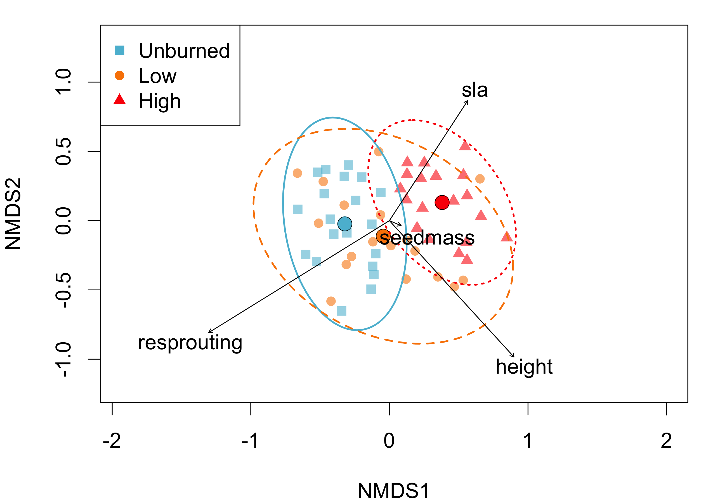

**Figure 1.** Results from the nonmetric multidimensional scaling (NMDS) analyses. Symbols represent individual plots in 2024 distributed according to taxonomic composition weighted by cover. Vectors indicate correlation between number of species with each trait and NMDS axes.

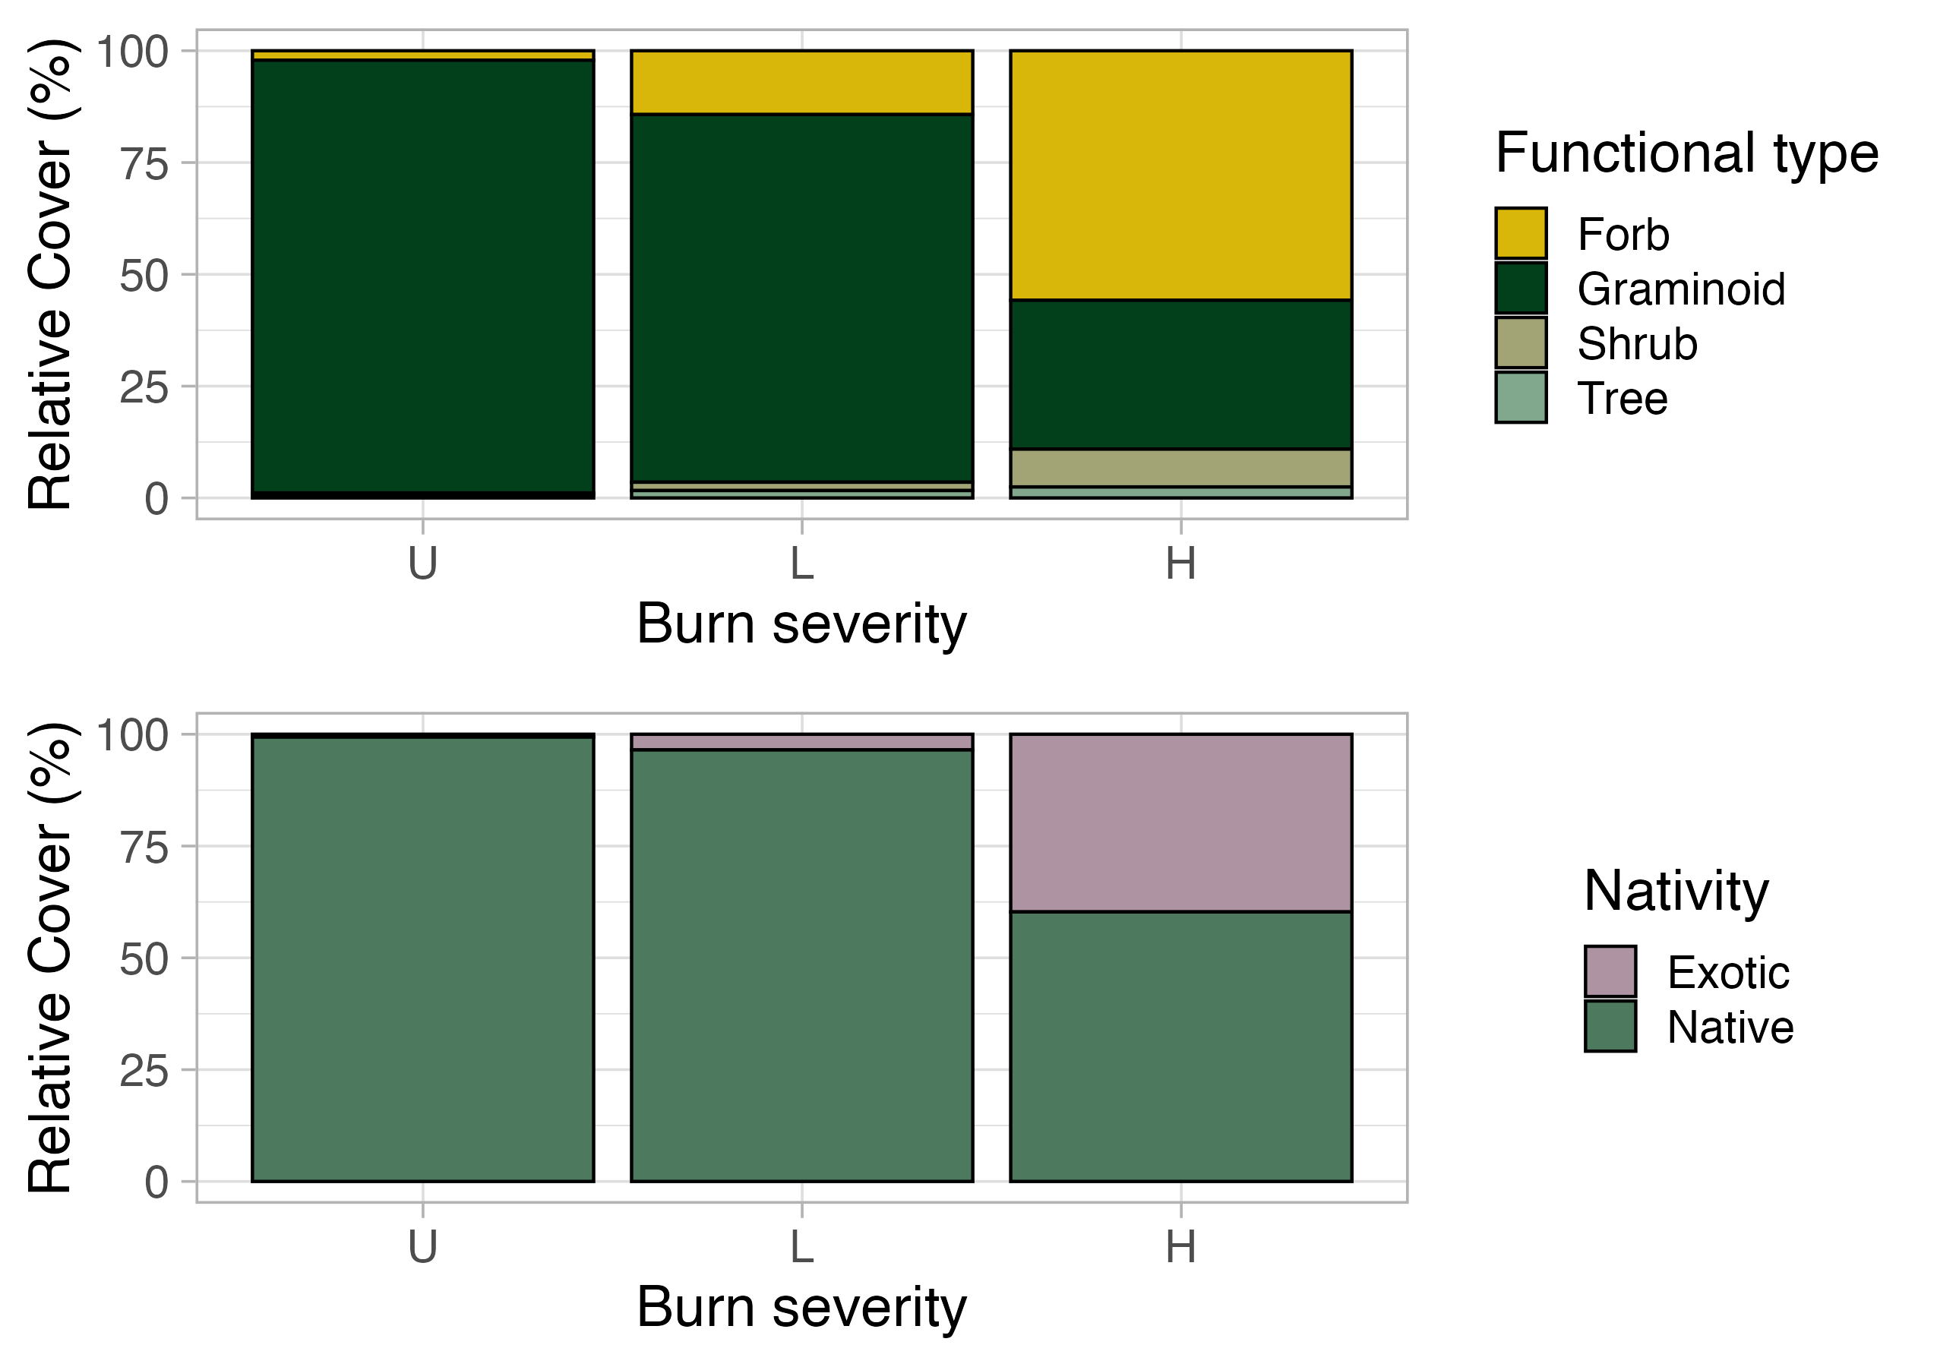

**Figure 2.** Relative cover for a) functional type across burn severity and for b) nativity status across burn severity.

**a)**

**b)**



**Table 1.** Indicator species for unburned, low, and high severity, with mean relative cover values. p-values = 0.05 < *#* *p* < 0.1; *p < 0.05; **p < 0.01; ***p < 0.001. Signiﬁcant terms are shown in bold; terms in italics are marginally signiﬁcant. 9,999 permutations.



**Table 2.** Indicator species analysis results with mean relative cover ± standard deviation, and number of plots in each treatment with species present. Bolded values indicate indicator status for the severity. Species with *IndVal* > 0.2 and *p* < 0.1 are shown. Cover values and number of plots are bolded for the fire severity that the species was an indicator for. Values in parentheses next to different fire severities indicate the number of plots per treatment.



**Table 3.** PerMANOVA results for taxonomic NMDS ordinations. p-values = 0.05 < *# p* < 0.1; *p < 0.05; **p < 0.01; ***p < 0.001. Signiﬁcant terms are shown in bold; terms in italics are marginally signiﬁcant.



**Table 4.** Pairwise Adonis comparisons of fire treatments on plot composition. Comparisons were conducted on plots distributed according to taxonomic composition weighted by cover. P-values were adjusted using the Bonferroni method. p-values = 0.05 < *# p* < 0.1; *p < 0.05; **p < 0.01; ***p < 0.001. Signiﬁcant terms are shown in bold; terms in italics are marginally signiﬁcant.



**Table 5.** Envfit results for taxonomic NMDS ordinations. p-values = 0.05 < *# p* < 0.1; *p < 0.05; **p < 0.01; ***p < 0.001. Signiﬁcant terms are shown in bold; terms in italics are marginally signiﬁcant.

**4. DISCUSSION**

Before the early 1900s, frequent, low-severity fires kept the dry conifer forests of western North America relatively open and park-like, with abundant fire-adapted perennial grass and forb cover dominating the understory (Biswell et al. 1973). However, as fire regimes have shifted away from historic norms, consequences for forest composition and structure have been drastic across the West. Here, we examined the responses of a ponderosa pine forest understory plant community to a fire severity gradient. We used functional trait data to better understand changes in understory composition.

In partial agreement with our first prediction, understory composition differed across all three severity classes (Figure 1, Table 3, Table 4). Based on both perMANOVA and tests of beta-dispersion, all three severity classes differed in centroids, while unburned and low severity plots differed in both centroids and beta-dispersion. Interestingly, the unburned plant community is a subset of the low-severity community. This result is consistent with past findings in forested ecosystems, where species richness is maximized at disturbance severities that match the historical disturbance regime (Miller & Safford 2020; Weeks et al. 2023). Furthermore, this pattern aligns with the intermediate disturbance hypothesis, where species diversity is maximized at intermediate levels of disturbance due to a balance between competitive exclusion and colonization opportunities (Connell 1978; Grime 1973). At our site, low-severity fire may have reduced competitive dominance by shade-tolerant or fire-sensitive species, creating some niches for disturbance-adapted species while also retaining some pre-fire community structure. The unburned plots, having missed recent natural fires or anthropogenic disturbances such as thinning or prescribed fire, likely reflect altered successional trajectories due to fire exclusion. Fire exclusion is known to reduce understory diversity and favor late-successional dominants (Covington & Moore 1994; Laughlin et al. 2004). In contrast, the composition of low-severity plots may reflect a community structure more in line with historical frequent-fire regimes, where periodic low-intensity fires maintained plant heterogeneity and functional diversity (Swetnam & Baisan 2003; Allen et al. 2002). These findings support theoretical expectations that ecosystem resilience and diversity are tightly coupled to disturbance regimes, particularly in fire-adapted systems.

Consistent with our second prediction, the compositional differences across burn severities were explainable with functional traits (Figure 1, Table 5). As fire severity increased, the plots were dominated by species with high SLA, no resprouting ability, and greater height. These traits are characteristic of ruderal strategies, which favor rapid resource acquisition, short life spans, and high dispersal capacity (Grime 1977; Diaz et al. 2016). High SLA reflects a strategy optimized for rapid growth in high resource, disturbance prone environments, while the absence of resprouting ability suggests a reliance on seed regeneration and opportunistic colonization following disturbances. Increased plant height may indicate competitive dominance for light in post-fire environments, where open canopy conditions and high resource availability favor fast growing species (Westoby 1998). In contrast, fire suppression likely selects for more stress-tolerant strategies, such as low SLA and resprouting ability, which are advantageous in shaded, resource-limited understories (Lavorel & Garnier 2002). Contrary to our prediction, seed mass did not vary significantly across the severity gradient, suggesting that local seed banks and post-fire environmental conditions played a larger role than seed morphology alone (Leishman et al. 2000). Overall, these patterns align with trait-based theories of community assembly, where disturbance acts as an environmental filter, selecting for specific combinations of traits that confer survival and reproduction under new abiotic and biotic conditions (Keddy 1992; McGill et al. 2006).

The use of indicator species analysis allowed us to relate the expression of community traits–and the ecological strategies associated with these traits–to the species that are representative of each severity class. The only indicator species for the unburned and low-severity plots were *Piptochaetium pringlei* and *Muhlenbergia straminea*, respectively, which are both perennial bunchgrasses. The high-severity plots had several indicator species, but the strongest indicator was *Verbascum thapsus*, which is a ruderal biennial forb. This is consistent with our trait vectors, which showed that traits associated with ruderality became more important in the high-severity plots. The remaining indicator species in the high-severity plots represent a variety of ecological strategies and include functional perennial forbs, perennial grasses, a legume, and the only shrub species in our data set (Table 1). This variety of indicator species may demonstrate that high-severity fire opened a greater breadth of niches, such that these functional groups could occur with greater consistency across plots. In other words, high-severity fire not only changed the composition of the understory, but also the ecological strategies of the species in the understory. Kuenzi et al. (2008) found similar results following the Rodeo-Chediski fire, which at the time of its ignition in 2002 was the largest and most severe fire in the southwestern United States. They found that low-severity fire was indicated by perennial bunchgrasses, while indicators of high-severity fire included ruderal species. Interestingly, as with our results, they found that high-severity fire increased the number of indicator species. These species included some of our high-severity indicators, such as *Lotus wrightii* and *Ceanothus fendleri*.

Several plant species were determined to be indicators of different fire severities, highlighting distinct community assembly processes under varying disturbance intensities. The perennial grass *Piptochaetium pringlei* was an indicator of the unburned area, while the perennial grass *Muhlenbergia virescens* was indicative of low-severity burns. In contrast, high severity-plots were associated with a more diverse suite of indicator species, including a shrub, two grasses, and four forbs—two of which (*Verbascum thapsus* and *Linaria dalmatica*) are non-native species introduced to the United States (USDA Plants). The presence of these exotics as high-severity indicators underscores the role of intense disturbance as a filter that removes established native competitors and facilitates community assembly dominated by ruderal and exotic species (D’Antonio & Vitousek 1992; McGlone et al. 2010)

Changes in functional group composition also reflects this disturbance-driven shift in assembly processes. With increasing fire severity, graminoid dominance declined sharply, while the relative cover of forbs, shrubs, and trees increased (Figure 2a). Unburned plots were dominated by perennial grasses, but relative graminoid cover declined by more than 50% from low to high severity. This shift suggests a breakdown in the persistence of the native grass dominated understory, a pattern that may be symptomatic of reduced resilience in the face of high-severity fire (Coop et al. 2020). The observed increase in forb cover was largerly driven by exotic species, further reinforcing the idea that severe fire creates open niches that favor fast growing, generalist species over more conservative perennials (Funk et al. 2008). This trend aligns with models predicting increased ruderality under intensified fire regimes, particularly when coupled with propagule pressure from non-native species ( Coop et al. 2022). This trend is consistent with observations that abnormally severe fires can favor woody species and trigger conversion to shrublands, ultimately contributing to an altered fire regime (Wang and Kemball 2005; Guiterman et al. 2022).

The invasion dynamics observed in this study may also be shaped by the social-ecological context of the site. Located within the wildland-urban interface of Flagstaff, Arizona, and subjected to high year-round recreational use, this area is exposed to elevated levels of anthropogenic propagule pressures. Human activity has long been recognized as a vector for exotic plant introductions (Kovarik and Von Der Lippe 2008), and high-severity fire may compound this effect by creating highly disturbed, low competition environments conducive to colonization by exotic species, ready to colonize severely burned areas in this ecosystem (McGlone and Egan 2009). The proximity of our study site to urban infrastructure–including roads, trails, and residential developments–has likely influenced the local species pool available for post-fire assembly of understory communities (Fowler et al. 2008). Together, these interacting filters—disturbance severity, propagule pressure, and trait-environment mismatch—are shaping novel plant communities with altered composition, structure, and potentially function, with implications for both ecosystem resilience and fire regime feedbacks (Keeley et al. 2011; Guiterman et al. 2022).

Our findings have important implications for land management in fire-prone ecosystems, particularly within the wildland-urban interface. Notably, the Museum Fire is unique in that no post-fire restoration interventions—such as seeding, mulching, or erosion control—were implemented following the 2019 burn. This lack of intervention is relatively uncommon, especially in areas adjacent to human infrastructure and recreational use, where even minimal restoration like wheat or sterile grass seeding for erosion control is often deployed. The absence of management at this site offers a rare opportunity to evaluate early successional dynamics under a passive recovery scenario and raises questions about the desired future state of these ecosystems.

The observed shifts in composition and functional traits within the first five years post-fire suggests that successional trajectories are already diverging from those that are characteristic of historically low severity fire regimes in ponderosa pine forests of western North America. As ecological theory and empirical studies suggest, community assembly following disturbance can have long lasting effects on forest structure, composition, and function (Seidl & Turner 2022). If management goals aim to promote the recovery of reference communities, such as low resembling low-severity plots, our results underscore the importance of early intervention through targeted post-fire restoration, including seeding or planting with native, fire-adapted species. Our findings suggest that without post-fire restoration actions, high severity fires could potentially alter community trajectories and subsequently ecosystem processes and functions. Differences in taxonomic composition suggest that restoration such as seeding and revegetation will be critical if understory communities reflective of the historic fire regime are desired.

The RAD framework (Resist – Accept – Direct; SOURCE) offers a useful lens for evaluating potential management responses in this context. A resist strategy would involve actively reseeding or replanting native species with traits characteristic of low-severity reference communities such as graminoids with low SLA and the ability to resprout, in an attempt to maintain historical composition and function. A direct strategy might guide succession towards an alternative but stable and desirable state, such as novel but native-dominated assemblages that are more resilient to increasing fire severity or climate change. Finally, an accept strategy—what has occurred here, by default—allows post fire succession to proceed without intervention, which, as our data show, has resulted in communities dominated by ruderal and often exotic species with high SLA and limited resprouting abilities. In this era of rapid global change, under an accept strategy, we might eventually see a vegetation type conversion from dry ponderosa pine forest to non-forested vegetation types (Barton 2002, Haffey et al. 2018).

Given this site’s proximity to recreational infrastructure and ongoing anthropogenic disturbance, a passive acceptance of these changes may have consequences for ecosystem function and future fire behavior and fuel structure. We have shown that community composition is altered within the first five years following high-severity fire. Long-term successional trajectories can be determined by the plant community that establishes immediately post-disturbance (Seidl and Turner 2022). Therefore, the altered understory community that we observed may have profound implications for the long-term ability of the reference community and canopy to recover. If reference communities are a desired management goal, our results underscore the importance of post-fire restoration. Our results suggest that if reference communities or ecosystem services associated with them are a priority, early and proactive restoration actions will be critical following high-severity fire.

Knowledge gap: is management capable of resist in this ecosystem? is it feasible at this point?

**5. REFERENCES**